WORLD MARITIME UNIVERSITY

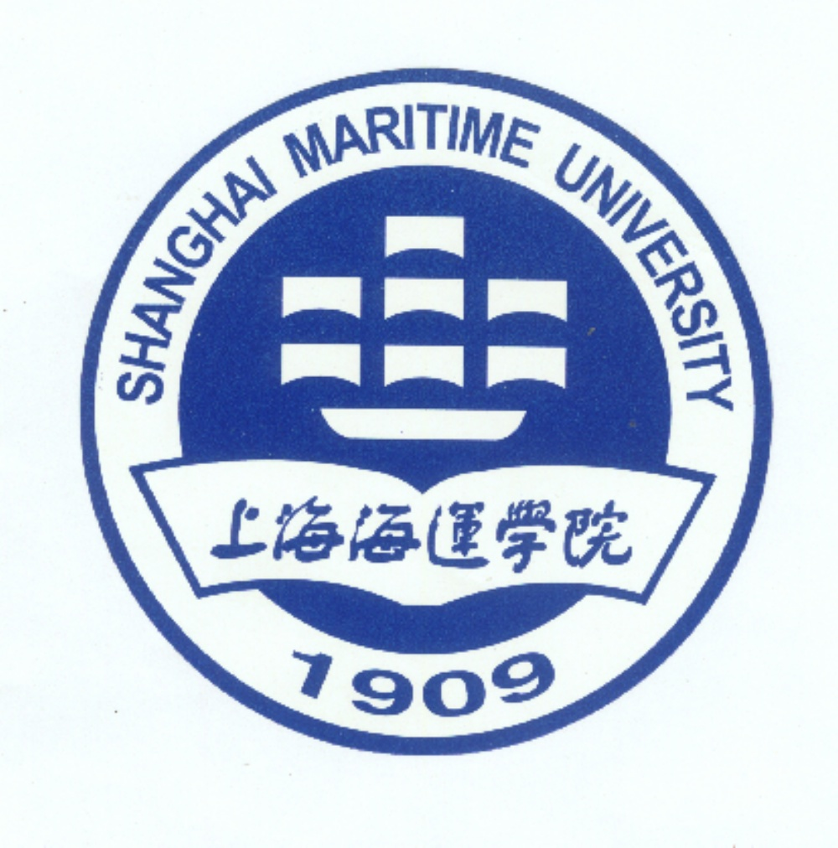
SMU
APPLICATION FOR ADMISSION TO THE
MASTER OF SCIENCE PROGRAMME IN

INTERNATIONAL TRANSPORT AND LOGISTICS
taught at

SHANGHAI MARITIME UNIVERSITY

__________________________________________________________________________________________

PERSONAL DETAILS

Family Name: (same as on passport): first name:

Date of birth: Gender: Marital status:

Citizenship: Passport Number:

Home address: Business address:

Telephone: Fax: Email:
__________________________________________________________________________________________

EDUCATION
Please list your academic qualifications, and attach certified copies of certificates and transcripts

University or equivalent Date Date Qualification Subject(s)
institution, city and country from: to: awarded:

___________________________________ ______ ______ ____________________ ____________

___________________________________ ______ ______ ____________________ ____________

___________________________________ ______ ______ ____________________ ____________

__________________________________________________________________________________________

ENGLISH LANGUAGE
Please note that all applicants (except native speakers) must attach a certified copy of an English language certificate

Date taken Result/mark
International English Language Testing System (IELTS) ____________ ____________

Test of English as a Foreign Language (TOEFL) ____________ ____________

Cambridge Examinations (PET/FCE/CPE) ____________ ____________

__________________________________________________________________________________________

COMPUTER SKILLS
Please note that all applicants must have computer skills. Please see the Academic Handbook for more details

Which computer software packages do you use regularly?

 word processing  Excel or other spread sheets  email/internet  other (please specify)

__________________________________________________________________________________________

PROFESSIONAL QUALIFICATIONS

Please list relevant professional qualifications, and attach copies of certificates

Institution, city and country Date Date Qualification Subject(s)
from: to: awarded:
___________________________________ ______ ______ ____________________ ____________

___________________________________ ______ ______ ____________________ ____________

___________________________________ ______ ______ ____________________ ____________

Do you have experience as a seafarer? YES / NO

__________________________________________________________________________________________

EMPLOYMENT
Please list the posts you have held over the last ten years, starting with your current job

Employer Date Date Position/Department
from: to:
___________________________________ ______ ______ _______________________________________

___________________________________ ______ ______ _______________________________________

___________________________________ ______ ______ _______________________________________

___________________________________ ______ ______ _______________________________________

___________________________________ ______ ______ _______________________________________

__________________________________________________________________________________________

APPLICANT'S DECLARATION
I certify that the statements made by me on this form are true, complete and correct to the best of my knowledge and belief. I understand that any false statements or omissions may provide grounds for the withdrawal of any offer of enrolment or for summary dismissal from the University.

If selected, I understand that I am expected to:
• conduct myself at all times in a manner compatible with my status as a student of World Maritime university;
• study full time during the period of the course, as directed by the University.

Signature: __________________________________________ Date: _________________________________

Please send the Application Form together with
1) copy of passport,
2) BSc or BA certificate,
3) Transcript,
4) English test – TOEFL or IELTS,
5) Two photographs
to:

Ms. Daisy Zhang
MSc in ITL, Shanghai Maritime University,

No.1336 Dongming Road, Pudong District,

Shanghai, 200126, China

Phone/fax: +86 21 58605519; Mobile: 86 180 0177 3003
Email: jiezhang@shmtu.edu.cn

